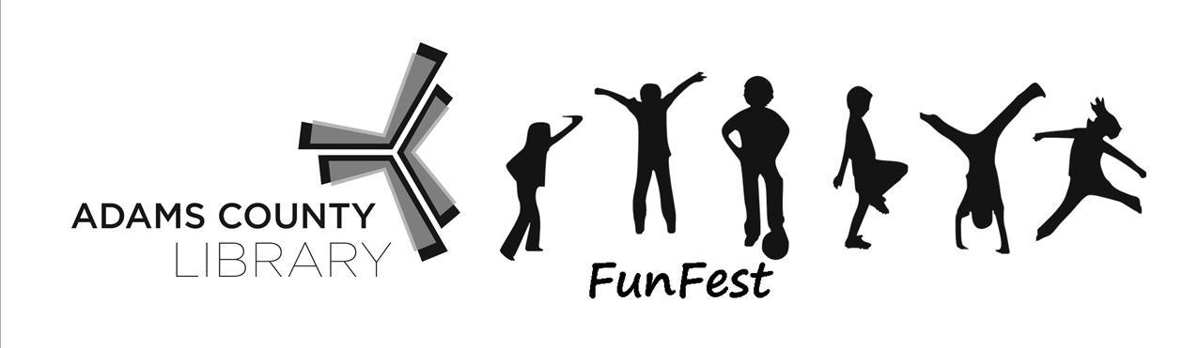
ADAMS COUNTY LIBRARY SYSTEM FUNFEST BOOTH APPLICATION

Event Date & Time: Friday, June 14, 2019 (Set up from 2p – 3:45p)
Location: Gettysburg Rec Park (545 Long Lane, Gettysburg)
Cost: $30/nonprofit or $75/business
Application Deadline to appear on most marketing materials: Monday, May 20, 2019
Deadline for all applications: Monday, June 3, 2019
Weather: FunFest happens rain or shine!
Library Event Contact: Dawn Smith: 303.968.7049 (cell) DawnS@adamslibrary.org

PLEASE READ THIS IMPORTANT FUNFEST EVENT INFORMATION BEFORE SIGNING AGREEMENT. Thank you!
LIBRARY PROVIDES: *One 10 x 10 or 10 x 20 space *Two chairs *Marketing in the Gettysburg Times, ACLS e-newsletter, ACLS website, posters, and social media *Electricity, if requested
BOOTH RENTERS PROVIDE: *10’ x 10’ or 10’ x 20‘canopy and weights/stakes *Tables (We can rent tables for you at $10 each) *Signage & banners to promote your business or organization
*Coupons or giveaways to help promote your business or organization
*An activity for the attendees. The activity can be for children, teens or adults. This year’s theme is A Universe of Stories and our goal is to have activities centered around space, exploration or the five literacies: basic, information, civic and social, health, and financial. So, if you can offer an activity that connects the work you do to space, exploration or any of those literacies, that would be fabulous!

PAYMENT INFORMATION ($30/non-profit booth; $75/business booth) Please make checks payable to the Adams County Library System and submit to: Adams County Library System, 140 Baltimore Street, Gettysburg, PA 17325 (To pay with credit card, please call Vicki Frist at 717.334.0163)

Upon receipt of completed application and full payment, we will contact you with further details about FunFest.

Indemnification by Booth Renter – Booth Renter agrees to hold the Adams County Library System and its FunFest Volunteers harmless from any liabilities incurred directly or indirectly by Booth Renter in any manner whatsoever involved with this Application Agreement. Further, the Adams County Library System shall not be liable to Booth Renter for any damages whatsoever or loss of any kind to their Exhibit or Products.

Licenses/Permits – Booth Renter shall be responsible for obtaining any licenses, permits, or approvals required under local or state law applicable to their activity at FunFest. Booth Renters are also responsible for all taxes.

Vendor Diversity – The Adams County Library System reserves the right to limit the number of
Booth Renters to ensure broad diversity amongst the Booth Renters.

Event Cancellation – Should any contingency prevent holding FunFest, the Adams County Library System shall not be held liable for any expenses incurred by the Booth Renter other than the rental cost of booth space.

Cancellation – If Booth Renter must cancel its space for good and sufficient reasons, and written notice of such cancellation is delivered to Adams County Library by Friday, May 17, 2019, Booth Renter shall receive a full refund of any booth fees paid. If cancellation occurs after May 17th, all booth fees are non-refundable.

PLEASE KEEP PAGES 1 AND 2 FOR YOUR RECORDS.

QUESTIONS? Contact Dawn Smith at dawns@AdamsLibrary.org * 717.334.0163 * 303.968.7049 Cell

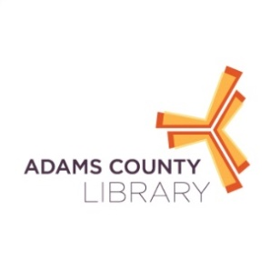

Please Complete This Page and Send with Payment to Dawn Smith,
Adams County Library System, 140 Baltimore Street, Gettysburg, PA 17325

Paying by Check? Please make checks payable to the Adams County Library System. Mail (or drop off) this page & check to the Adams County Library System, 140 Baltimore Street, Gettysburg, PA 17325

Paying by Credit Card? Please call Vicki at 717.334.0163 and then scan and send this page to Dawn at
DawnS@adamslibrary.org.

BOOTH CONTACT INFORMATION
Organization Name_____________________________________________________________________
Organization’s Mailing Address____________________________________________________________
Contact Name_____________________________________Contact Cell__________________________
Contact Email_________________________________________________________________________
(If different than above)
Day of Event Contact______________________________DOE Contact Cell________________________
DOE Contact Email______________________________________________________________________
PLEASE CHECK BOOTH SIZE _____10 x 10 _____10 x 20 Other________
I NEED ELECTRICITY FOR MY BOOTH _____Yes _____No
I WOULD LIKE TO RENT TABLES ($10 EACH) _____Yes: _____Quantity $_____Total
I WOULD LIKE TO RECEIVE EVENT POSTERS _____Yes _____No Quantity______
I WILL SHARE THIS EVENT ON SOCIAL MEDIA _____Yes _____No
FOOD VENDORS ONLY
Please provide a copy of your food vendor license to Dawn Smith at DawnS@AdamsLibrary.org by June 1, 2019. Please list the food/beverage items you plan to sell, and their prices.
_____________________________________________________________________________________
I have read and agree to the information provided with this application.
Booth Renter Contact Signature___________________________________________Date____________
Total Amount Enclosed________________

